October 2017 Newsletter.

St. Conleth’s National School, Derrinturn.

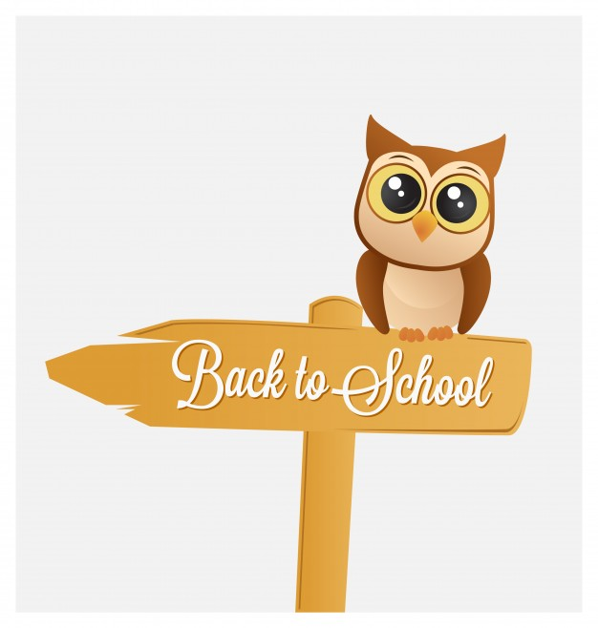 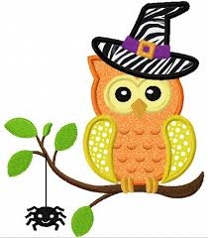

**Contents** Collecting Children p. 1

Gaelic News p. 1

Green Schools Event p. 2

Team Hope p. 3

Parent Teacher Meetings p. 4

Upcoming Events p. 4

Contact Details p. 4

Contacts p. 4



**Collecting Children**

Please note that the children have breaks from 11am until 11.10am and from 12.30pm until 1pm. Should you wish to collect a child for an appointment, we request that you arrive before or after these times. It is very difficult to locate the children during these times. The time it takes to find children in the playgrounds is very likely to cause a delay.



12.30pm – 1pm

11am – 11.10am

**Gaelic News!**

Mrs. Colleary’s under 11 team have been battling it out on the Gaelic field of late and have had some major successes. It’s always very hard to get a team up and running so early in the school year, but our superstars were up for the challenge. Mrs. Colleary is part of the successful Carbury ladies team and has lots of inspiration and coaching tips for the lads. They trained hard and took all her advice on board. Victories abounded as they took on and defeated Ardclough and Confey. Eventually the boys went on to the semi-final, where the boys fought very hard to the final whistle, but were beaten by a very strong Nurney team.

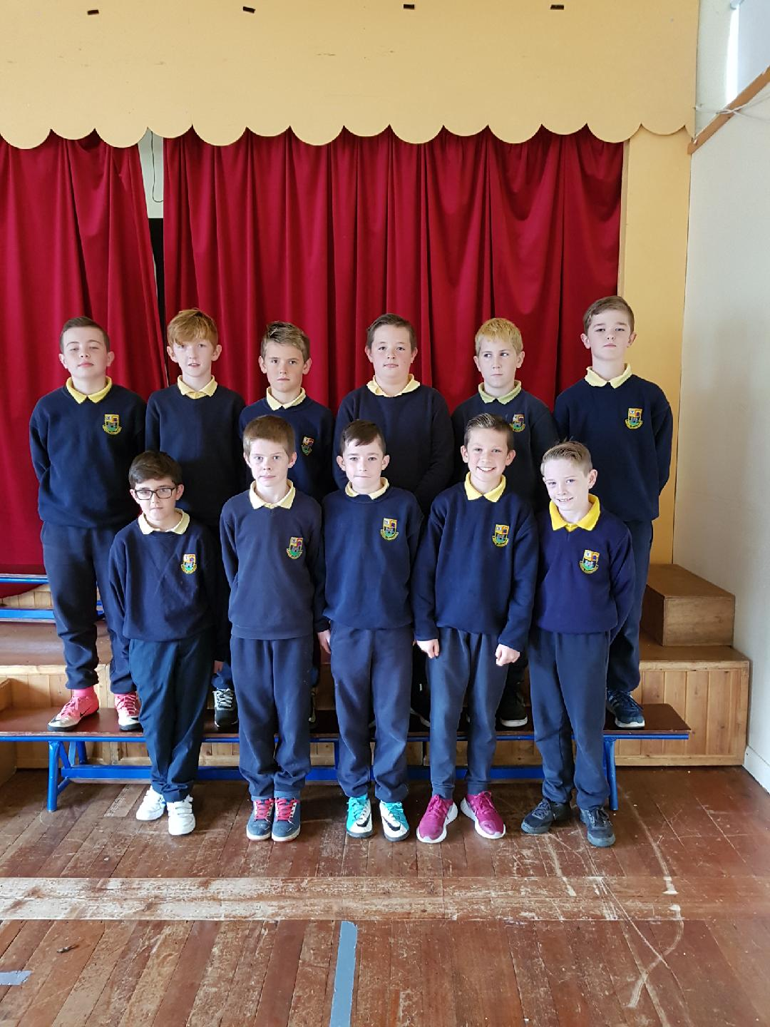

Team members: Ben Kearney, Troy Kearney, Jack Byrne, Adam Walsh, Seán Cassidy, Brandon Saunders, Joey Boyle, David Fennessy, Tom Norton, Joe Fitzgerald, Liam McNamee. Missing from photo: Aaron Behan, Ryan Connolly and Oisín Malone.

**Green Schools Event**

On Tuesday 14th November there will be a clothing collection in aid of Green Schools at St. Conleth’s National School. Our Green Schools activities and events have always been self-funding, through various recycling and green-themed activities. In November we will team up with LENREC LTD> Lenrec Ltd. is a recycling company, providing a quality national collection from schools, churches, community centres and sports clubs. They are conveniently located in Kilkenny, with easy access to all counties, Lenrec Ltd supports charities by its works including ‘Friends of Calcutta’ and the ‘Susie Long Hospice Fund’. They have been established for more than eight years and have in-depth knowledge of the recycling industry. They are fully licensed and registered with all county councils in the Republic of Ireland.

|  |
| --- |
| The Green Schools Committee have chosen the November collection date so that everyone can have time during the mid-term break to sort out their winter wardrobe. **From November 6th onwards, items may be brought to school.** Please donate all your unwanted clothes, bed linen, towels, curtains, shoes, bags, belts and soft toys.  NO HOUSEHOLD BRIC A BRAC  Wearable clothes will be recycled and re-used. Other items will be recycled and might become industrial wipes or soundproofing materials.  THANK YOU IN ADVANCE FOR SUPPORTING THIS FUNDRAISING DRIVE.  Image result for www.lenrec.ie  **WHAT WE COLLECT** |

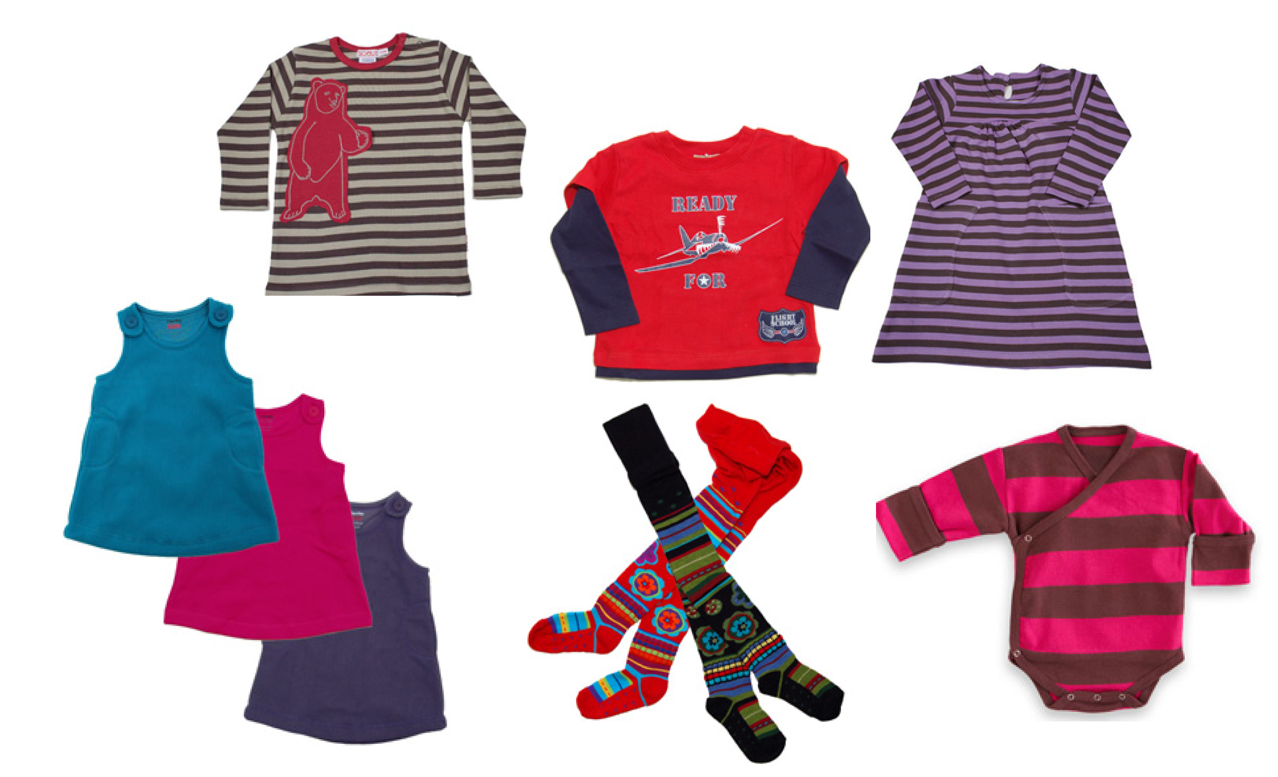 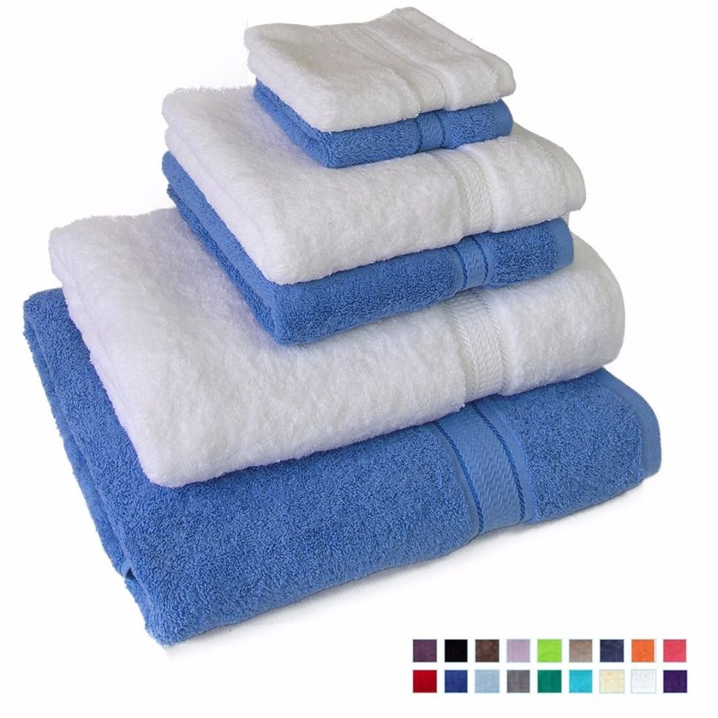  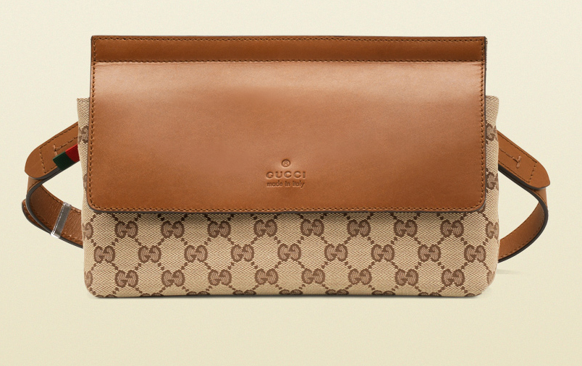

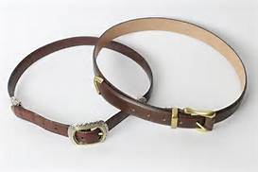  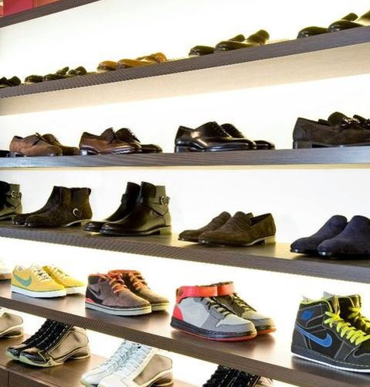 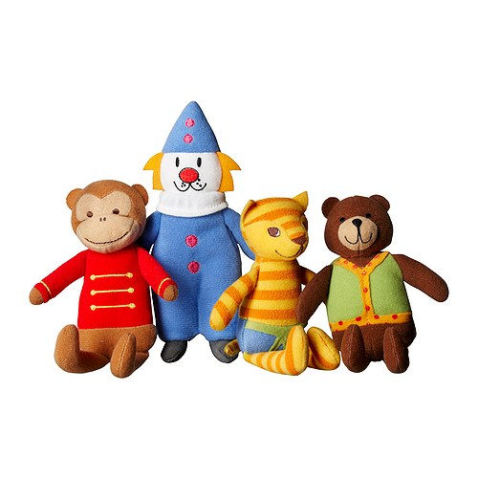

**Clothing Towels Bed Linen Bags**

**Belts Curtains Shoes Soft Toys**

NO Mobile phones Laptops Tablets

Mats/carpets Duvets/pillows Books



For several years now different classes have taken part in the Team Hope Christmas Shoe Box Appeal. We also held a very successful Shoe Box Appeal for the Homeless. The children and parents have always been very generous and thoughtful at this time of year and we have decided to support this appeal again this year.

We give your Christmas Shoebox gift right into the hands of some of the world’s most vulnerable children – many of whom will receive no other gift this Christmas. For some it’s the first gift they’ve ever received.

Preparing your shoe box gift is very easy. Fill a shoebox with a range of simple Christmas gift, drop it into school before **November 10th**, and we will do the rest. **5 simple steps to follow**

1. **Grab a Shoe box.** Wrap the box and lid separately with Christmas paper.
2. **Ask your teacher for the boy/girl label** and choose who you want to give your Christmas Shoebox to and what age.
3. **Fill the box.** Get as creative as you like and have some fun with this ! – You can use the 4 W’s as a rough guide
4. **Close the box**. Include €4 in your leaflet envelope either on top of the gifts or taped to the inside of the lid. Sometimes children work in groups of four to cover the cost of the box.

**THE 4 W’s**

Please put in a selection of small gifts from the options below: (but out of respect for the children we ask that all items be new, or good as new) **TO WRITE –**Items for school – like a pen, pencil, copy book, paper, colouring book, felt pens, sharpener, eraser, solar calculator. **TO WASH –**Some hygiene items – toothbrush and toothpaste, soap (wrapped please), facecloth, hairbrush, comb. **TO WEAR –**Small clothing items – a hat, scarf, gloves, socks or underwear **WOW ! –**A treat – sunglasses, game, small Irish gift, a photo of yourself, sweets (must be in date until at least March 2018), make up, a small musical instrument, toys like a doll, a car, cuddly toy, skipping rope, yo-yo, a finger puppet… even a ball is fantastic.

Team Hope’s fantastic volunteers work hard to check that all Christmas Shoeboxes meet with customs and safety requirements, they seal them and send them on their way by truck or shipping container. Then their international partners will deliver your shoebox right into a child’s hands – in hospitals, schools, shelters, churches, orphanages, community centres, mountain villages and family homes.

It’s hope, it’s God’s love, it’s joy and excitement –

***It’s the whole of Christmas wrapped up in a Shoebox !***

***THANKS!***



Parent Teacher Meetings

Our Parent Teacher Meetings will take place in November. Your child will bring home your appointment letter. We have made every effort to accommodate families and have scheduled meetings for siblings consecutively. We ask that you try to keep to the schedule. If you need more time an appointment can be made for another date. Time is precious on the given dates, but alternative arrangements can easily be made.

Parent Teacher Meetings



Your meeting provides an opportunity to see how your child is getting on in school, where strengths and weaknesses lie, how your child socialises with other children in the classroom, the playground, during extra- curricular activities etc. You will have an opportunity to voice any concerns you might have. It is also a chance for your teacher to learn more about your child in order that you can work together for your child’s success. As our school motto says:– “Ar Aghaidh le Chéile.” We look forward to meeting you all at the meetings. We value the close ties our school has with you and we hope to work hand in hand to help each of the children in our care to reach their full potential.



Friday 27th October: Bring and Buy

Friday 27th October: School closes for Mid-term break.

Monday 6th November: School re-opens.

November (Dates vary): Parent Teacher Meetings

Tuesday 14th November: Clothing Collection

Wednesday 22nd November School Closed – Staff Training.

  

is coming. soon

website

Our new

St. Conleth’s National School, Derrinturn, Carbury, Co. Kildare. E-mail: **secretary@stconlethsns.ie**

Telephone : 046 9553490