A Great Start to the School Year.
Welcome back to a new school year. All the children have settled very well into their new classes. On page two of the newsletter you can find out about some improvements we made during the summer holidays. The school is constantly improving and developing and we thank everyone for the help and encouragement that you give to us here at St. Conleth’s. As we start into the new school year, we direct your attention to some of the policies on our school website, www.stconlethsns.weebly.com on the Policies tab. Please read the Homework and Healthy Eating Policies. The parents of new Junior Infant classes attended an information evening, but it is important to remind ourselves (and the children) of our expectations. The Communications Procedure is also in this section of the website. This explains how best to make contact with the school. We take this opportunity to remind you that the first port of call for any queries about your child should always be the class teacher. He or she is the first point of contact with the team that work with your child. The Code of Behaviour is very important too and the children have brought home a form for parents to fill in before October 9th. The Enrolment Policy will change this year in order to comply with new legislation. We have a few tips for you, as parents starting the school year: Remember to set good example for your children. They copy what you do, so please set an example. At school, we set an example of politeness and consideration. When your children get into the car after school, let them tell you about the day. Your children need sleep. Do not let them stay on phones or tablets all night. Feed your children well. Breakfasts matter. Snacks and hydration are necessary during the day. Things do go wrong. Please tell us if you have concerns. Discussion and appropriate intervention should happen early on. Your children could be bullied at some point. This is the reality, especially in the world of social media. This does not mean the school is unsafe. Children can be cruel to one another. Reassure your child and support the school to resolve the issue. Encourage your child to be kind, not bear a grudge, even if you think they were 100% the victim, and to stand up for their friends. Social Media can be harmful! We should monitor phones and devices. It is good parenting and good practice. Have a wonderful year. We are always available. Feel free to make contact with the office.

Contents:
A Great Start to the School Year p. 1
School Self Evaluation p. 1
Keeping in Touch p. 1
Updates & Upgrades p. 2
Updates & Upgrades continued p. 3
Important Events p. 4
Fundraising Event p. 4
Contact Details p. 4
St. Conleth’s N.S. Newsletter

School Self Evaluation
The School Self Evaluation process will continue this year. School self-evaluation is a collaborative, inclusive, reflective process of internal school review. It is a way of working that involves reflective enquiry leading to action for improvement. It is informed and steered by evidence gathered within each school’s unique context. Very soon, you will receive a questionnaire about Science. The children will also complete questionnaires. It is important that we gather the opinions and suggestions of everyone. We ask you to complete and return the questionnaires. The information will inform the evaluation and direct our future progress, as we formulate our School Improvement Plan. The information you provide will form a very important part of our data-gathering as we strive to plan ahead for our school. We look forward to engaging with this process and we are anxious to hear your views.

Keeping in Touch
Please inform the school if you have changed your address or telephone numbers. We may need to contact you or send school texts.

Updates
& Upgrades
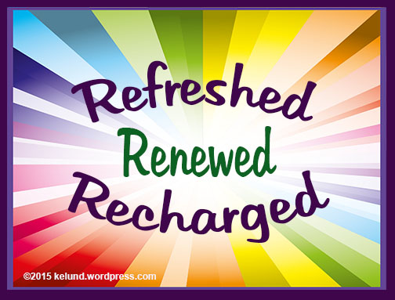
We’ve been very busy during the summer, preparing for the school year that lies ahead. The children deserve the very best that we can provide and we have really worked hard to ensure that such provisions are made for the children. We are very lucky in Derrinturn to have a committed and dedicated community that help us in every possible way. We owe a debt of gratitude to all that have helped us over the years, but we extend a particular thanks to all that have helped us with our developments during the summer holidays.
The hall has had a facelift. The stage has been brightly painted in the Carbury colours and it looked fantastic during the graduation ceremony in June. However, the curtains needed a makeover. Without any hesitation, one of our parents stepped in and volunteered to sew for us. The curtains are perfect and we are very grateful. We have managed, over the years to raise funds through our Christmas presentations and carol services. We have bought nativity costumes, lighting, a radio microphone, a Bluetooth amplifier and an electric piano with your kind donations. This summer another talented parent built a storage unit for our equipment. It is all stored safely and tidily in sturdy timber units. As if this wasn’t enough, the members of St. Conleth’s Boxing Club offered to lend a hand as well. They volunteered to provide the labour necessary to revamp the hall floor. This was a mammoth task, involving long hours and hard work. We are delighted with the hall and thank everybody involved.
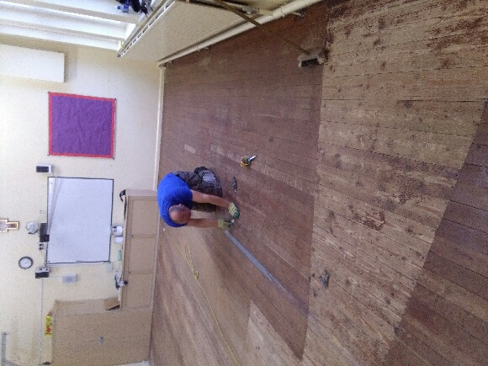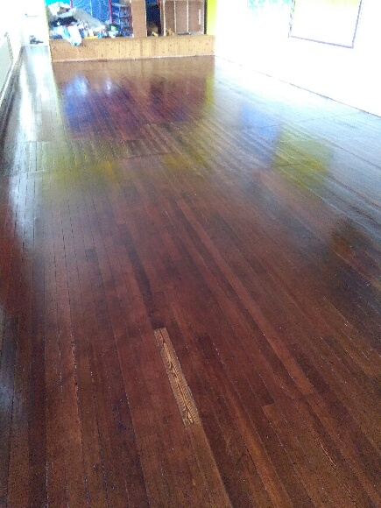
We have also evicted Mrs. Kirk from her office. The room is now a beautiful, peaceful Oratory. It is a tranquil space where members of the school community (children, staff, parents…) can withdraw for a few moments of reflection or prayer. We have been involved in the ‘Meditation for Children’ programme for several years at St. Conleth’s. This has been effective and had a huge impact on the wellbeing of all at the school. Last year we set up our Oratory in a temporary home. We discovered that the room was too big and impersonal and we wanted a smaller, quieter, more accessible room. The Oratory is open to everybody and we have already seen individual children and small groups taking time out for a little personal time in the room. We know that the mental health and well-being of our children is critical to success in school and life. Education about mental health and well-being is an integral part of the school curriculum. We hope that everybody will benefit from being able to take a

little time to withdraw from the hustle and bustle of everyday life and to spend some quiet, peaceful, reflective time in the beautiful space that has been created for us. In such a busy and pressurised world, it is wonderful to have a quiet space in which to spend some time.
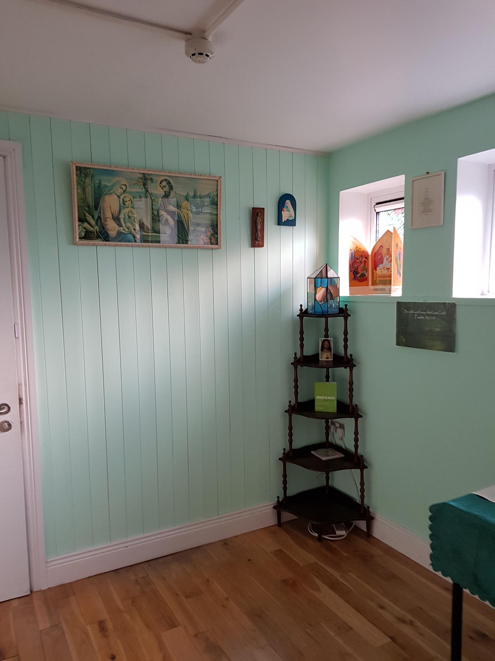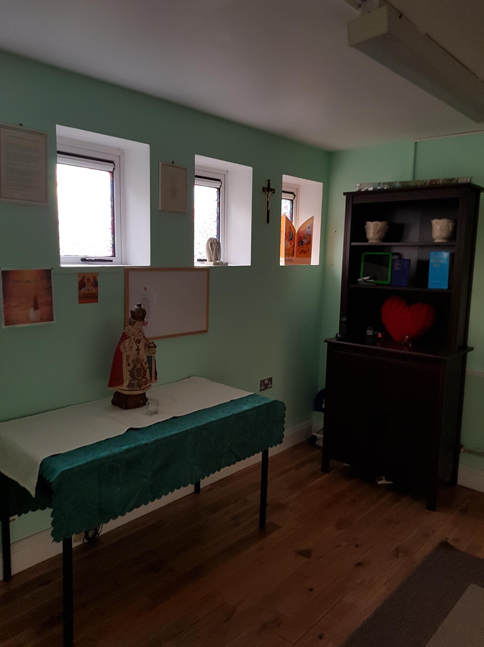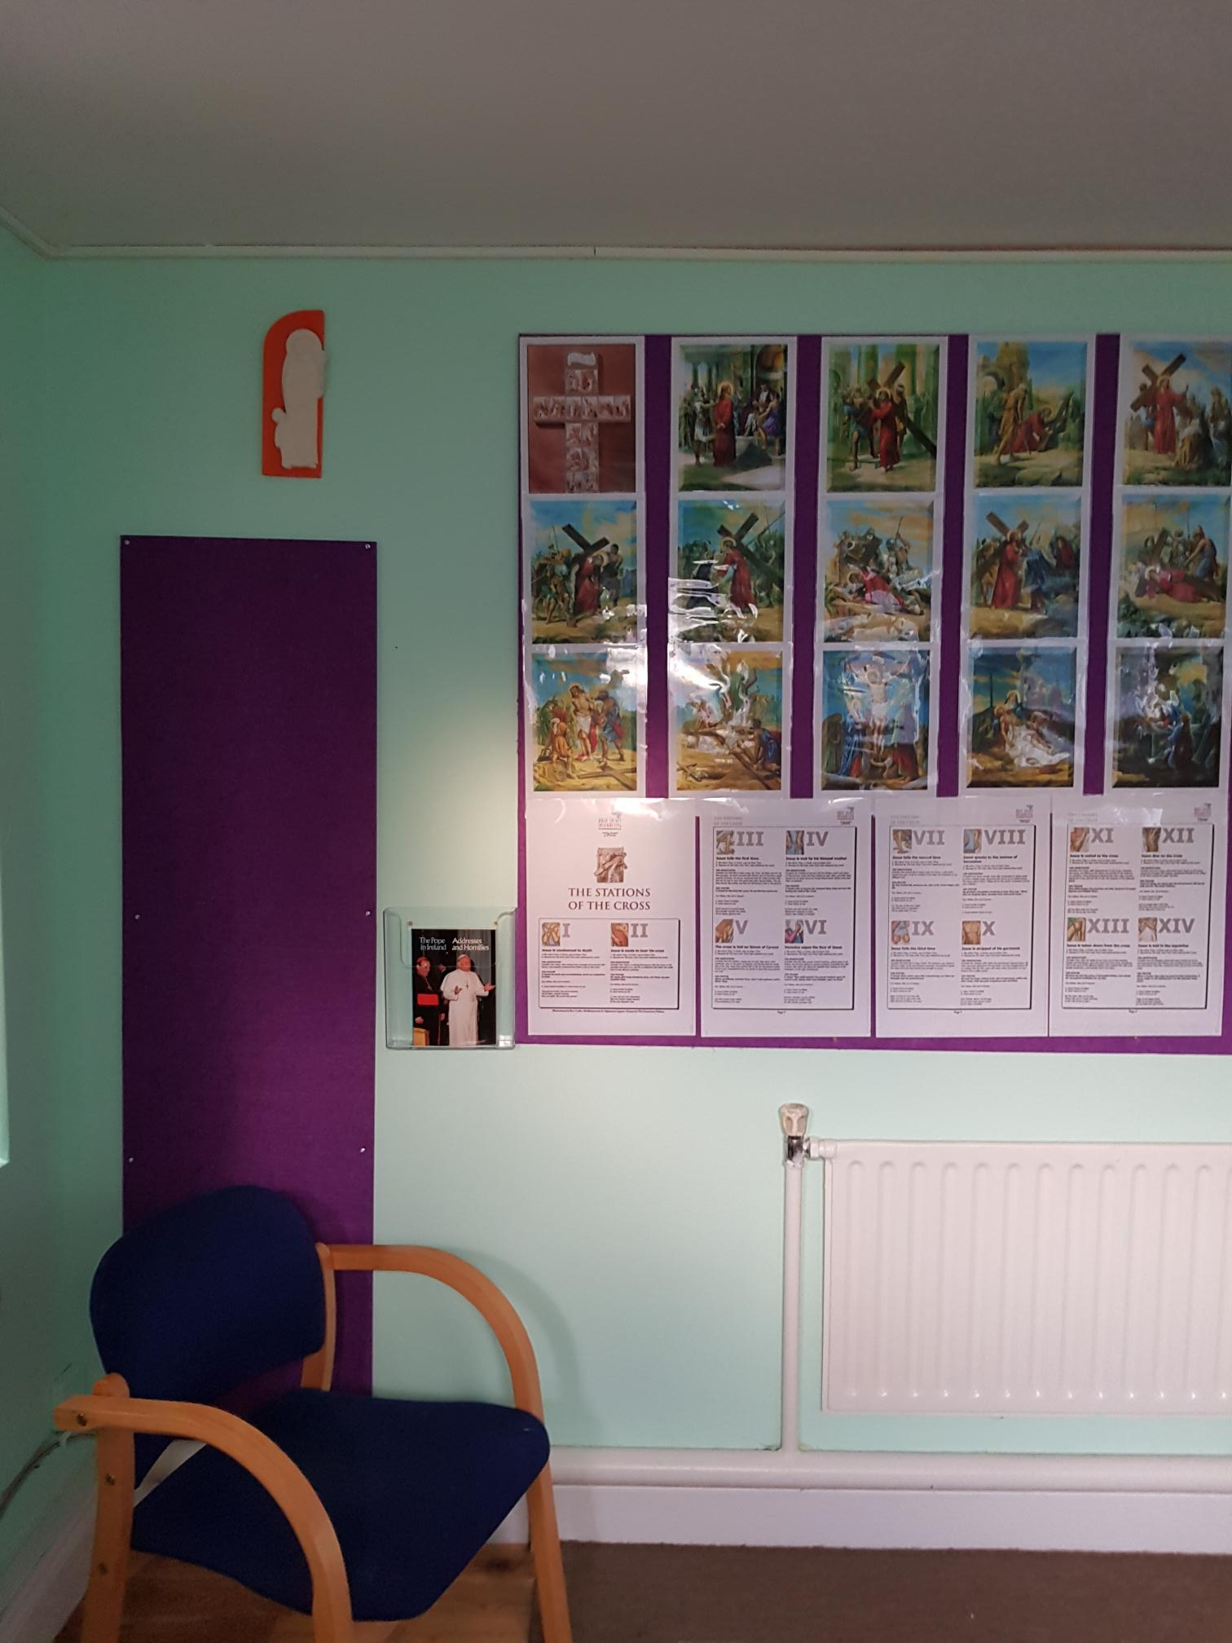
By far the most exciting new addition to the school is our new library, which we call “HAPPILY EVER AFTER.” The children have been waiting excitedly for the final few finishing touches to be added to the room and we are delighted to announce that it is finally finished. The children have been listening to a story on assembly called ‘The Adventures of the Wishing Chair’ by Enid Blyton. It is an old, but timeless book that tells of imaginative journeys. We know that the children will take many imaginative journeys as they read books and we are really proud of the new library and the chances it affords the children to engage with books. We know that many happy hours will be spent in “Happily Ever After”. We thank everybody that has donated books and we have invested in many new texts. We are also about to introduce a new reading programme at school called ’Accelerated Reading’. It will link our Digital School Strategy with our new library and the children will use an online system to track their reading progress. All of these developments will be of benefit to our children and we thank everybody that made the dream of a school library become a reality. We look forward to seeing the children enjoy all our updates and improvements. The hall, the oratory and the library are wonderful facilities. We have enjoyed the hard work and we feel that it is definitely worth it. We extend our thanks again to all those that donated and volunteered time and expertise. It is a wonderful example of our school motto, “Ar aghaidh le Chéile!”
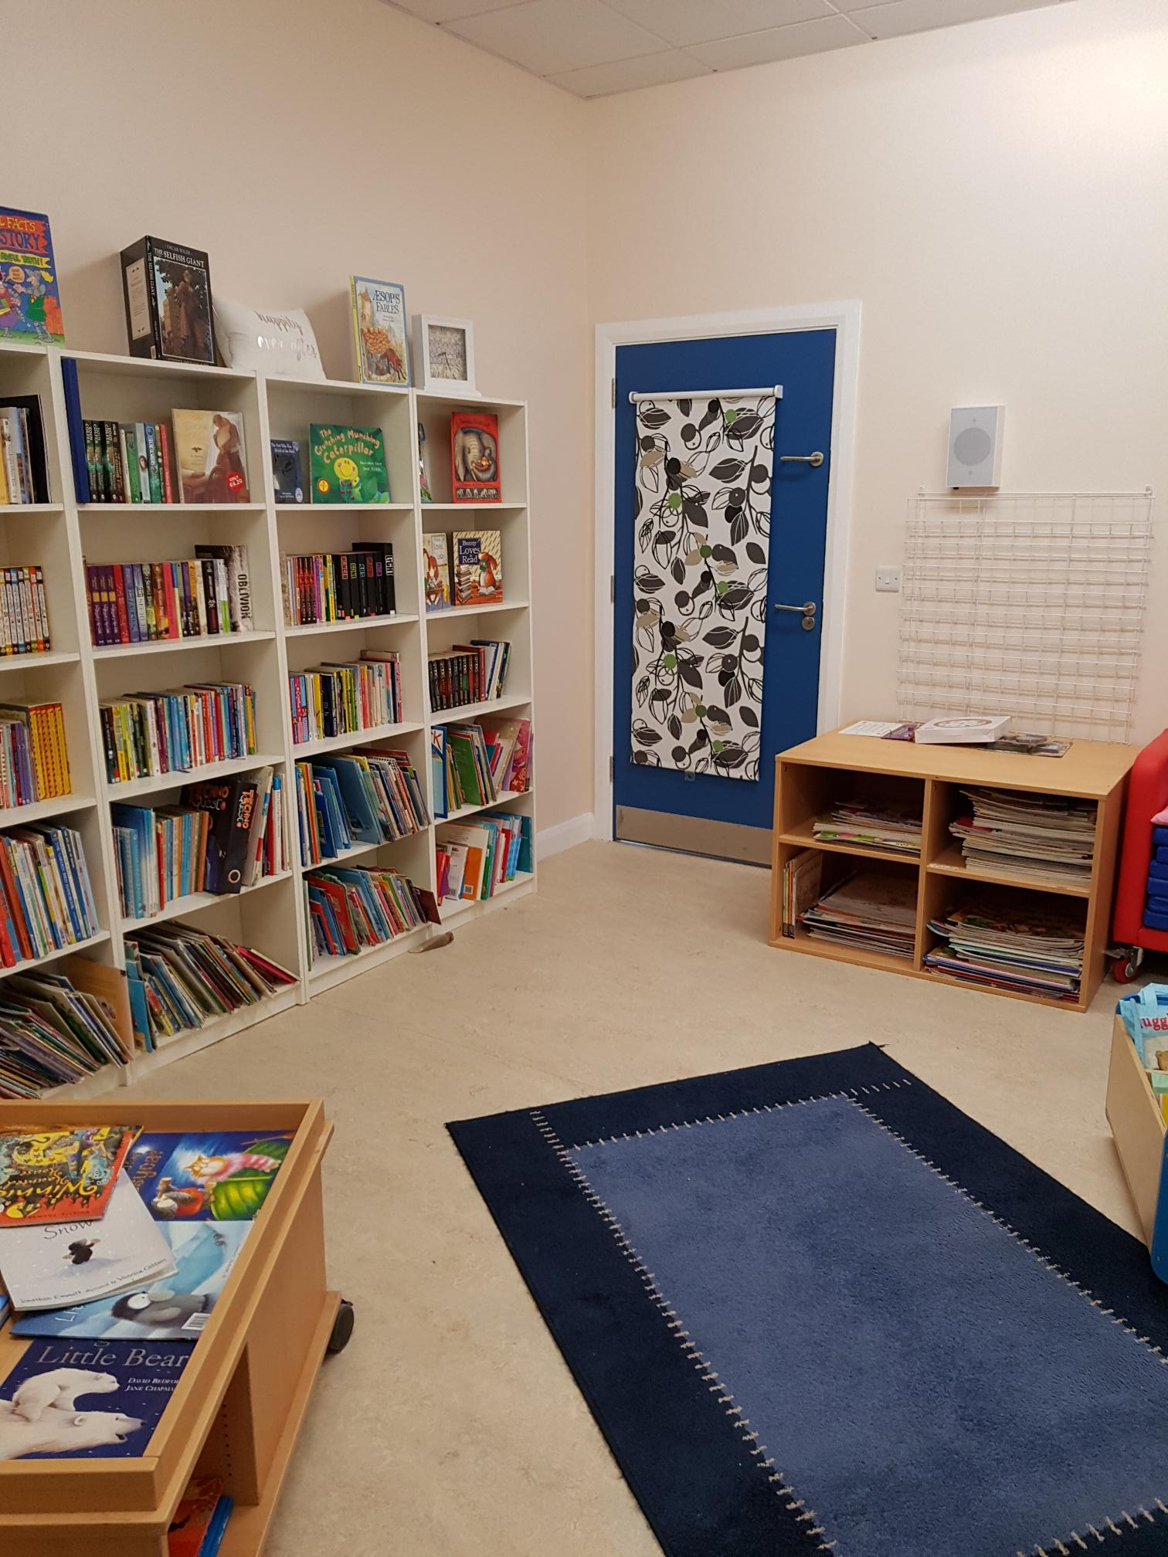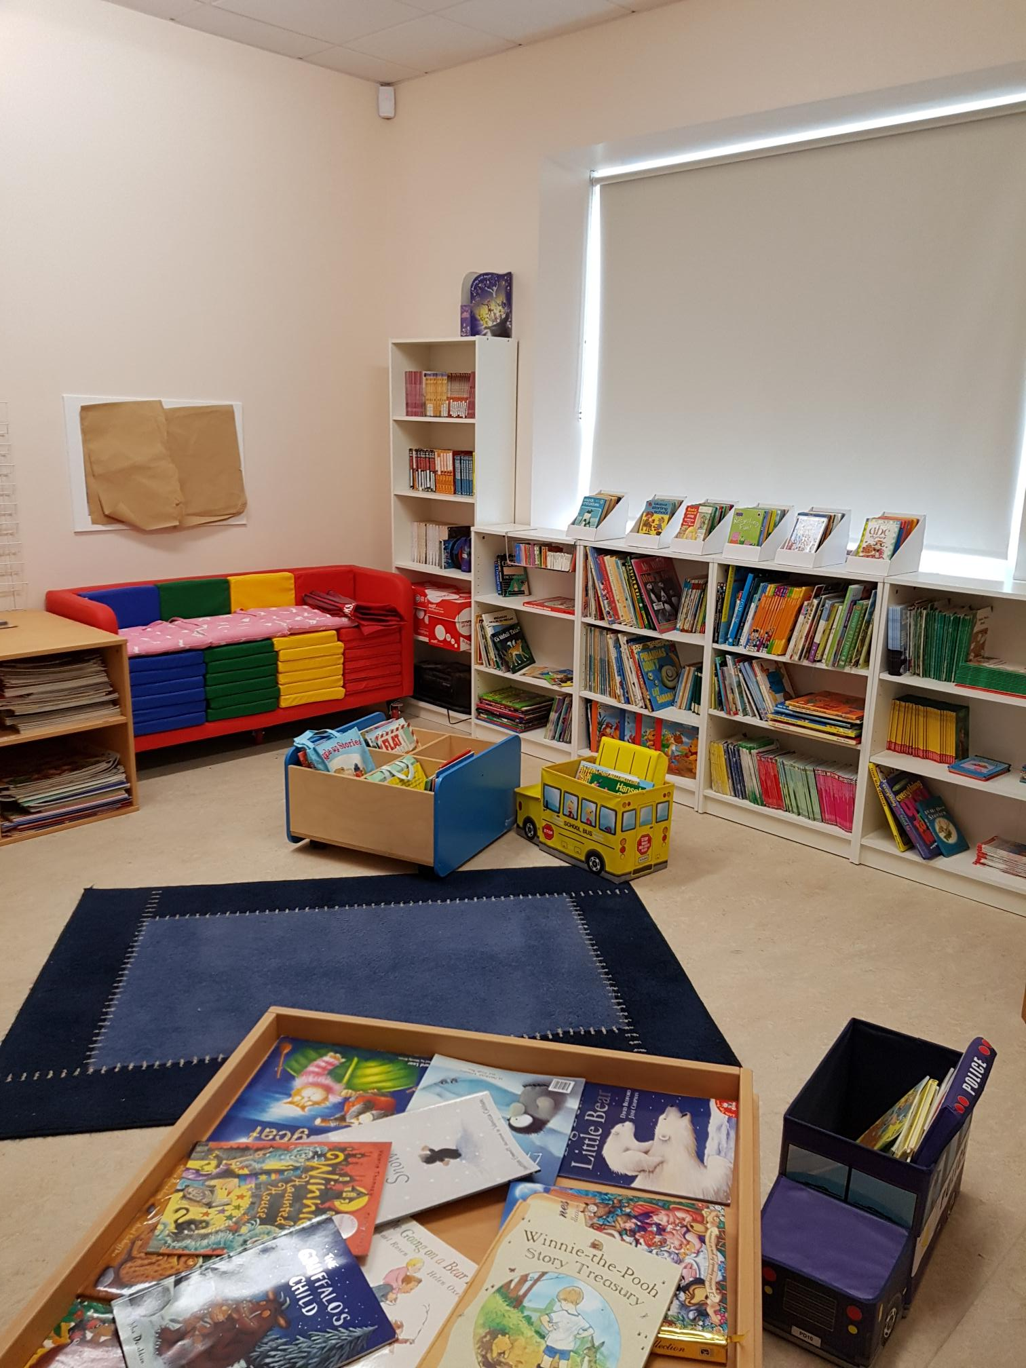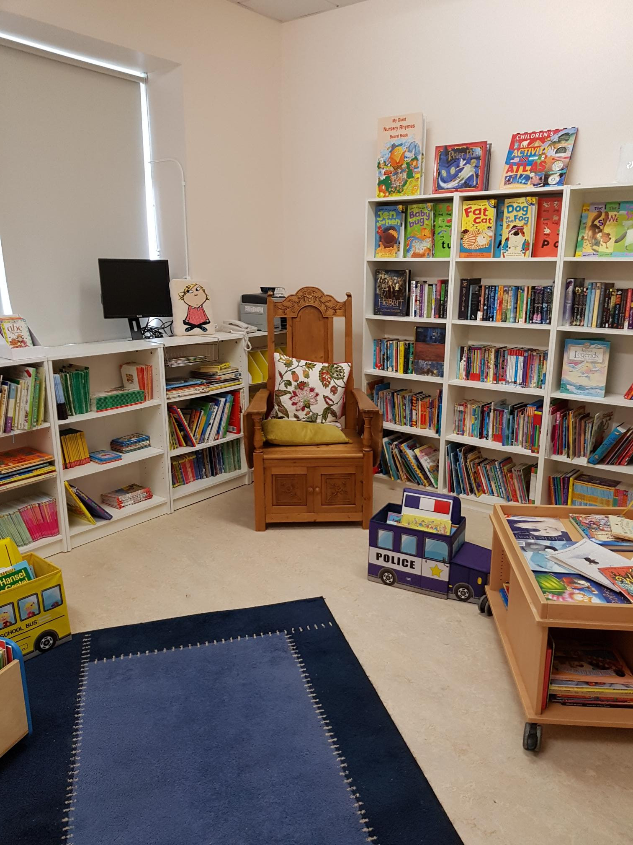

Important Dates
Communion Meeting for Parents October 1st
Clothing Collection October 5th
Return Date for Code of Behaviour Forms October 9th
Non-Uniform Day for Parents Association October 12th
AGM of the Parents Association October 16th
Presidential Election (School Closed) October 26th
Halloween Break Closing October 25th
Re-opening November 5th
Erasmus Visitors November 7th
Confirmation February 27th
First Confession March 7th
First Holy Communion May 25th

Fundraising Event for Green Schools.

There will be a clothing recycling drive in aid of
ST.CONLETH’S NATIONAL SCHOOL
on
FRIDAY 5TH OCTOBER 2018
Please drop off all items between Monday 1st October and Thursday 4th October
Please donate all your clean, unwanted, re-usable clothes, bed-linen, towels, shoes, bags and belts.
NO HOUSEHOLD BRIC-A-BRAC

THANK YOU!
All funds raised go towards our children

CONTACT DETAILS
St. Conleth’s National School, Derrinturn, Carbury, Co. Kildare.
Tel: 046 9553490
E-mail: secretary@stconlethsns.ie
Website: www.stconlethsns.weebly.com

www.stconlethsns.weebly.com
Important Notice.
The Education (Admissions to School Act) was signed into law in July 2018. All schools are currently working on any necessary changes to enrolment policies and admissions procedures. One of the requirements is that parents sign up to the school’s Code of Behaviour.
The Code of Behaviour of St. Conleth’s National School is available to read on our school website, www.stconlethsns.weebly.com.
Please read the Code of Behaviour and discuss it with your child or children. Then complete the form attached below. Signed forms should be returned to the class teachers before October 9th 2018. A separate form is needed for each child. Thank you for your co-operation.

- - - - - - - - - - - - - - - - - - - - - - - - - - - - - - - - - - - - - - - - - - - - - - - - - - - - - - - - - -
Declaration of Acceptance of the Code of Behaviour of St. Conleth’s National School.

Pupil’s Name: ___________________________________________________________

Pupil’s date of birth: _____________________________________________________

Name of Parent/Guardian 1: _______________________________________________

Name of Parent/Guardian 2: _______________________________________________ (If applicable)
I (We) confirm that we have read the Code of Behaviour of St. Conleth’s National School and that we understand the Code of Behaviour.
I (We) confirm that I/we as parent/guardian (parents/guardians) accept and agree to support this Code of Behaviour why my (our) child is attending St. Conleth’s National School.
Signed Parent/Guardian 1: _______________________________________________

Signed Parent/Guardian 2: _______________________________________________

