**St. Conleth’s N.S.,**

**Derrinturn**

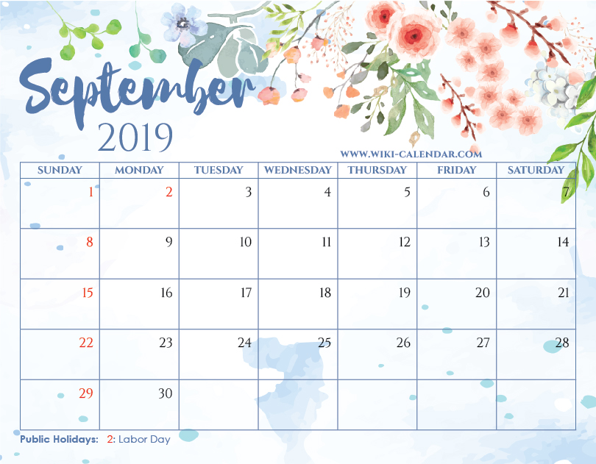  

**Contents** PAGE 1: Code of Behaviour It takes a village to raise a child. PAGE 2: Community Garden Helpers Sacramental Classes Allenwood Soccer Club Donation PAGE 3: Digital Age Guidelines PAGE 4: School Calendar 2019 – 2020 Contact Details

**Code of Behaviour** During the early stages of the year, the children discuss the Code of Behaviour with school staff and they work with the class teachers to create their own class rules. This is a lovely early experience of democracy for them and all the class rules are worded positively after the children define the parameters. On enrolment at the school, the children and parents accepted the Code of Behaviour and agreed to abide by this Code. We revise the basic rules each September with your children so that they are familiar with routines, procedures and aware of the fact that there is structure, order and safety. Please discuss the class and school rules with your children as they are particularly proud of the class rules they have been involved in drafting.

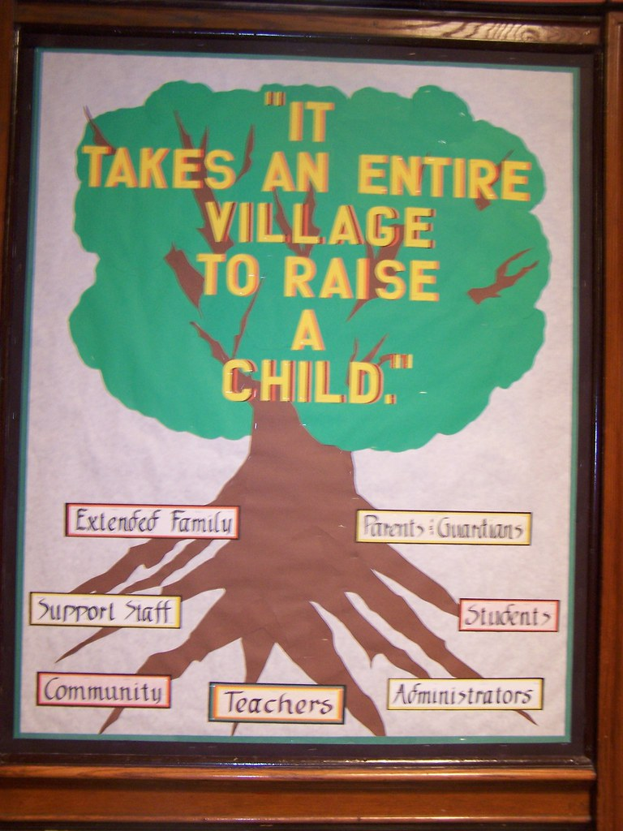

**“It takes an entire village to raise a child.”**

It takes a village to raise a child is an African proverb. It means that an entire community of people must interact with children for those children to experience and grow in a safe and healthy environment. The villagers look out for the children.

At St. Conleth’s National School we are very lucky to have the support and cooperation of the local community and we take this opportunity to thank everyone for such support. You are always ready to help the children. You eagerly (and with great energy and enthusiasm) contribute to fund-raising activities, complete questionnaires, offer help, engage with staff, support and attend our activities and events.

Every interaction that children have has an impact on their lives and we are very proud that the school and the wider community work so well to educate our children together.

As we start another school year, the Board and Management and staff of St. Conleth’s National School take this opportunity to thank all members of the community for their help, support and encouragement. We depend upon your continued support. We have no doubt that as the school year progresses, there will be many opportunities for further engagement. We know that we will be asking for help with clothes recycling, Bring and Buys, Cake Sales etc. We encourage you to actively engage with school activities and support the children. Parent activities will appear in the newsletter and on the school website. We hope to provide plenty of opportunities for further cooperation this year. We know that it will, as always, be a very busy and productive year. For this reason we are very anxious to convey to you our sincere appreciation for all that you do for the school and the children. We may forget to say this as we get engrossed in schoolwork, but please know that we are very grateful to you all. Thank you so much.

**Community Garden Helpers.**

Members of the Community Garden Group will be working in school each week with some of the children. The children are going to start a gardening group and it is hoped that each child will experience the fun of growing plants at school at some stage during their time at our school.

The children already take responsibility for the chickens and our duck as part of our Green Schools Programme and what better way for them to progress than to develop green fingers. Gardening helps develop responsibility and patience. It develops teamwork, social skills and inter-dependence.

There will be an obvious link between this project and our Science curriculum. Children will learn about what plants need to live and as they progress through the school, they will more readily learn about the parts of a plant and processes such as photosynthesis. There is an open-air science lab on our doorstep and we look forward to using it.

We thank the Community Garden volunteers and we look forward to watching our garden grow. More details will follow in Newsletters during the year. We hope to post loads of pictures on our school website, [www.stconlethsns.weebly.com](http://www.stconlethsns.weebly.com).

**Sacramental Classes**

This will be a very important year for our Sixth and Second Classes as they prepare for the Sacraments of Reconciliation (First Confession), the Eucharist (First Communion) and Confirmation. It is important that the children prepare for the sacraments at school and at home.

The new Religion Programme, ‘Grow in Love’, is now in use in all classes. There are homework assignments in the books and we encourage you to engage with this programme. Look at the books and ask the children what they have learned in Religion time. The new programme is easily accessible and colourful and the children thoroughly enjoy the lessons.

If your child is in Second or Sixth Class and does not wish to take part in sacramental preparation, please let the school office know as soon as possible. Lists of children are prepared very early in the year.

The Parish arranges meetings for parents and will call on volunteers to engage with the preparation [programmes. ”You](mailto:programmes.@You) Shall Be My Witness” Is the Confirmation Programme and “Do This in Memory” is the Communion Programme. Perhaps you would consider becoming involved with the committees and making this sacramental journey with the children. The Parish community supports and enriches the experience for the children.

As soon as dates for the programme meetings have been arranged, we will let parents know. We will also let you know as soon as dates for the sacraments have been decided upon.



**Allenwood Soccer Club Donation**

Our thanks are extended to Allenwood Soccer Club, who organised a fundraiser for local schools during the summer holidays. They have donated money raised to our special classes.

The club intend to organise ‘football for all’ sessions during the coming year and coaches are training at the moment. This would enable all children to participate in soccer. Special thanks to Jennifer Brereton, who worked so hard to organise events.

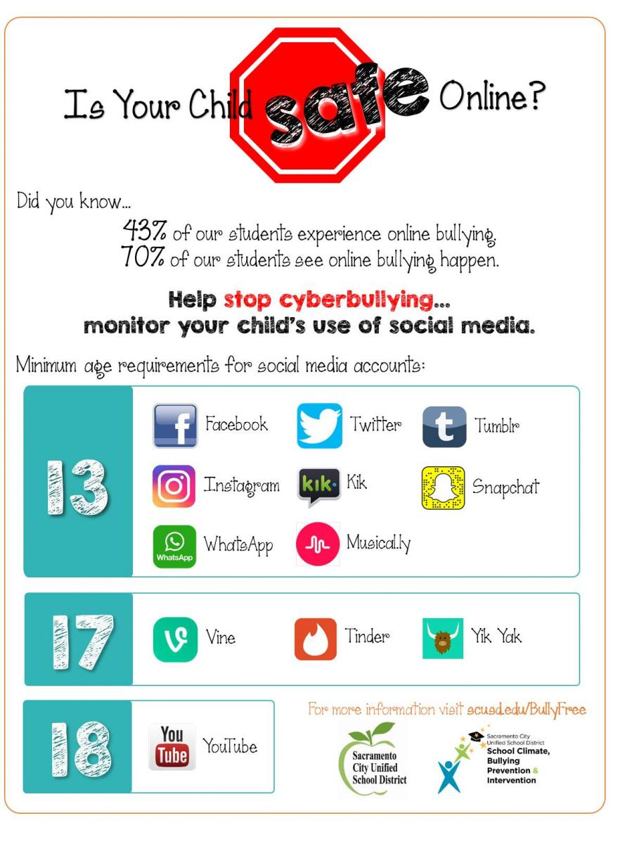

Working together, we can help our children.

**School Calendar 2019 – 2020**



**School will be closed as follows:**

**September: Monday, 2nd – School re-opens after the Summer Holidays.**

**October: Tuesday 15th October – Closed for Teacher In-Service Training**

**Monday, 28th - Hallowe’en Break. Tuesday, 29th – Hallowe’en Break.**

**Wednesday, 30th – Hallowe’en Break.**

**Thursday, 31st – Hallowe’en Break.**

**November: Friday, 1st – Hallowe’en Break.**

**Monday 4th - School re-opens after Hallowe’en Break**

**December: Friday, 20th – Closing for Christmas Holidays.**

**\*\*\*\*\***

**January: Monday, 6th – School re-opens after Christmas Holidays.**

**February: Thursday, 20th – Mid-term Break.**

**Friday, 21st – Mid-term Break.**

**March: Monday, 16th – St. Patrick’s Weekend.**

**Tuesday, 17th – St. Patrick’s Day.**

**April: Friday, 3rd – Closing for Easter Holidays.**

**\*\*\*\*\***

**Monday, 20th – School re-opens after Easter Holidays.**

**May: Monday, 4th – Bank Holiday.**

**Friday, 29th – Bank Holiday Weekend.**

**June: Monday, 1st – Bank Holiday Weekend.**

**Friday, 26th – Closing for Summer Holidays.**

**\*\*\*\*\***

Alsoi school details Teachers

Any Other gems can also be added

CONTACT DETAILS St. Conleth’s National School Derrinturn, Carbury, Co. Kildare. W91 KC79

Tel: 046 9553490 E-mail: [secretary@stconlethsns.ie](mailto:secretary@stconlethsns.ie) Website: [www.stconlethsns.weebly.com](http://www.stconlethsns.weebly.com)