

**St. Conleth’s N.S.**

**Newsletter**

 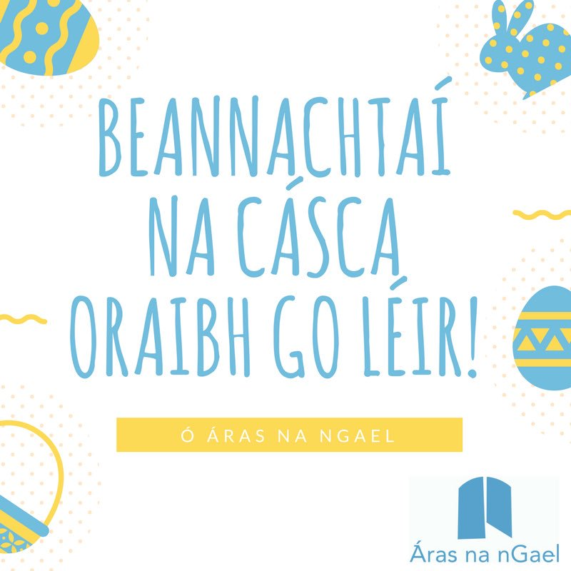

CONTENTS

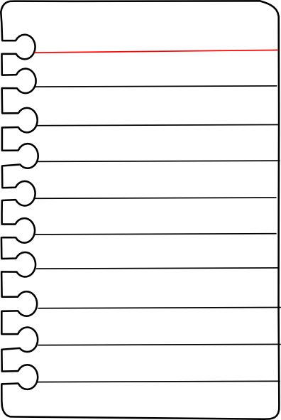 

Page 2

Safeguarding Children Diary Highlights Contact Details

Page 1

Autism Awareness Day Success

*Sincere thanks to everyone for supporting our fundraiser on our Blue Day.*

*We raised €735.63. Thank you to everybody.*

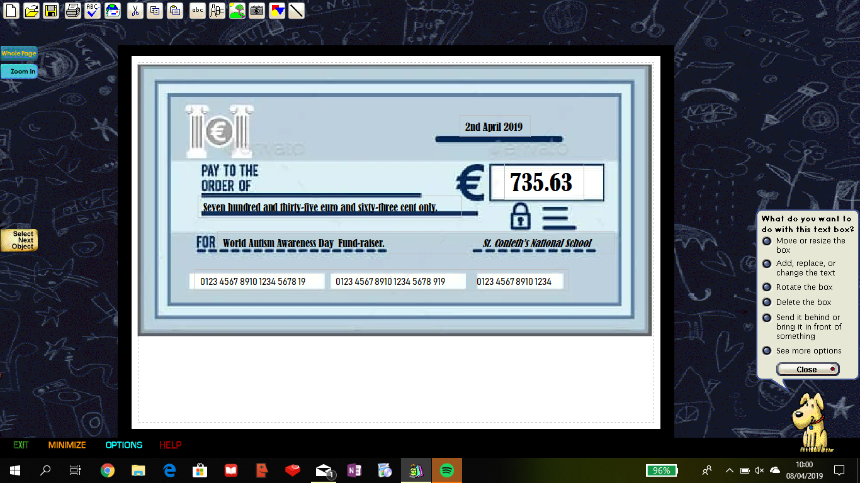

Garda Patrol Due to recent anti-social behaviour on the school grounds after school hours, Gardaí have agreed to patrol the area at night. School property has been damaged and it is becoming more regular. It is illegal to trespass and to cause criminal damage. We thank the Gardaí for their assistance. We ask you all to help us to take care of our school and provide a safe, clean learning environment for our children. Please let us know if you see anything untoward. Thank you.

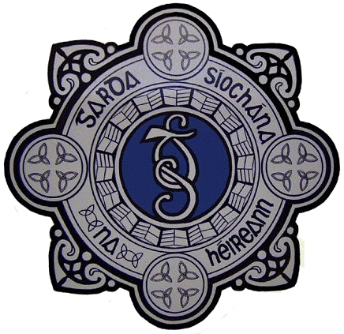

Safeguarding Children The Board of Management of St. Conleth’s National School have conducted the annual review of the Safeguarding Children Statement. The Statement is displayed inside the school door along with the Risk Assessment. 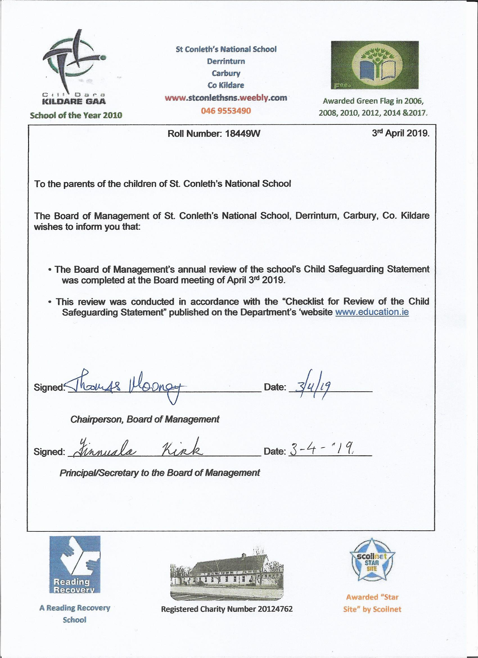

It is vital that adults in school are vetted and that the school staff are aware of any visitors to the school. Visitors are requested to sign the visitors when they arrive at school and to sign out when they leave.

We are concerned at the number of adults on the school corridors each morning. Please note that the children are collected by the teachers in the yard each morning. If the children are late, they should be dropped to the front door, not to the classroom door. Nobody should pass the electronic door without signing the book.

This measure is in place for the protection of all of the children in the school. There are children with needs and children that are anxious about strangers. You are known to some children, but not to all. Please respect the needs of our children at St. Conleth’s National School. Thank you.

 

School Closures

**Easter Holidays** Closing on Friday April 12th at 12 noon.

Re-opening on Monday April 29th

**Referendum – Closed as polling station** Friday May 24th

**First Holy Communion** Saturday May 25th.



CONTACT DETAILS

St. Conleth’s National School, Derrinturn, Carbury, Co. Kildare.

Tel: 046 9553490

E-mail: [secretary@stconlethsns.ie](mailto:secretary@stconlethsns.ie)

Website: [www.stconlethsns.weebly.com](http://www.stconlethsns.weebly.com)

**www.stconlethsns.weebly.com**

**www.stconlethsns.weebly.com**

 

CONTACT DETAILS

St. Conleth’s National School, Derrinturn, Carbury, Co. Kildare.

Tel: 046 9553490

E-mail: [secretary@stconlethsns.ie](mailto:secretary@stconlethsns.ie)

Website: [www.stconlethsns.weebly.com](http://www.stconlethsns.weebly.com)