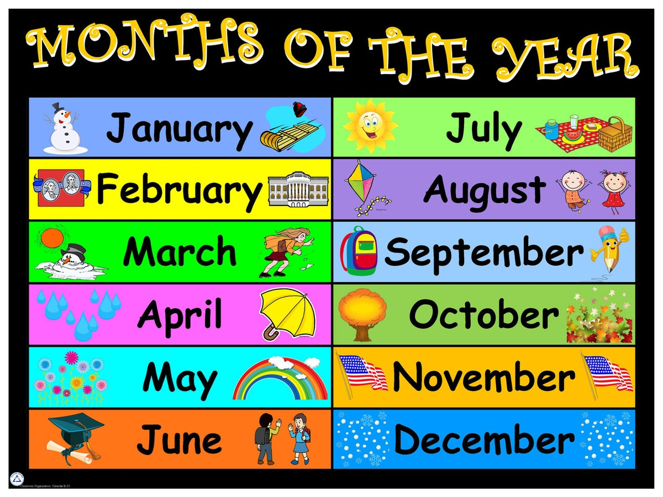

Contents:

Christmas Jumper Day p. 1

Homeless Charity Appeal p. 1

Parents Association p. 2

Christmas Concerts p. 2

Contact Details p. 2

Holiday Notice p. 2

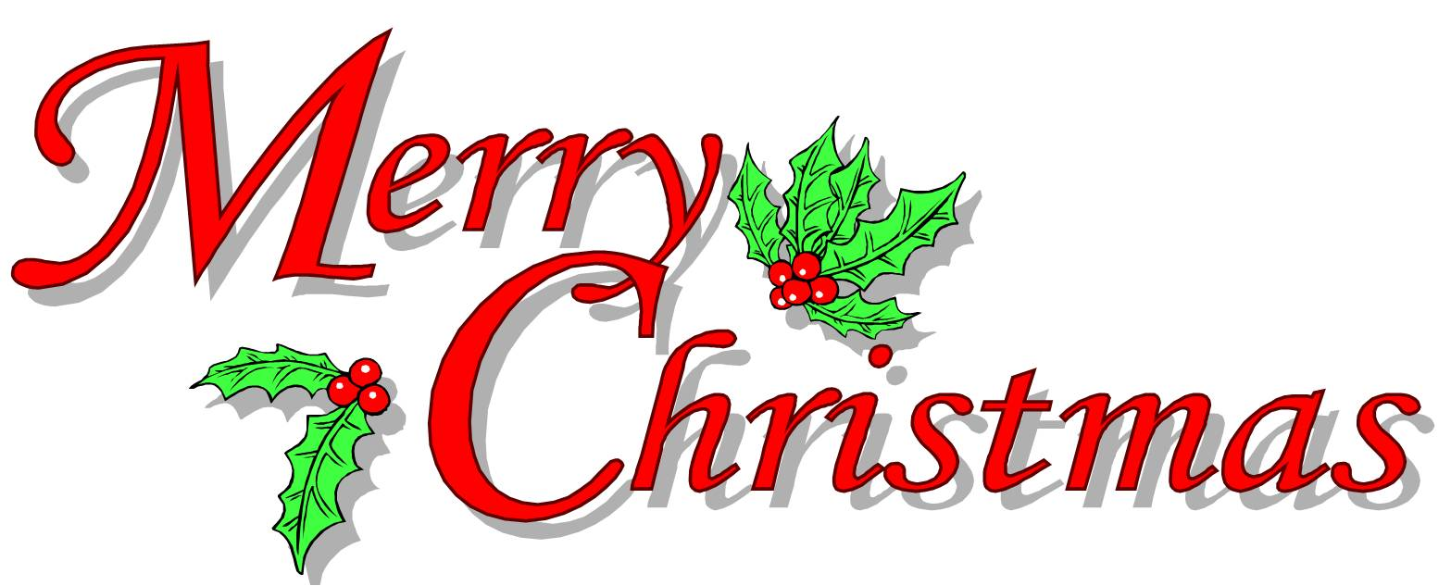



**St. Conleth’s N.S. Newsletter**

Christmas Jumper Day

Christmas Jumper Day will be held on the 20th December. We hope to raise funds for the Children’s Medical Research Fund, Crumlin Hospital. The children will may wear their Christmas style, while raising funds and awareness for this great cause.

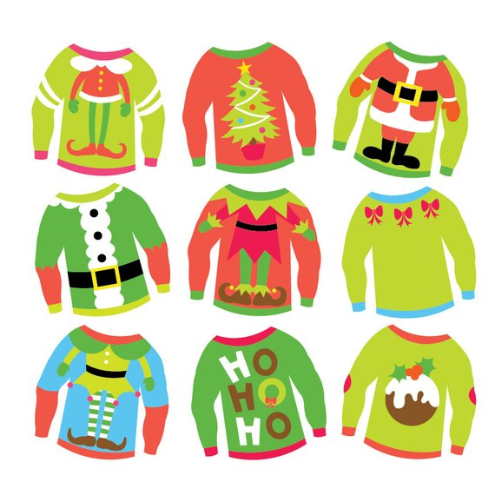

Local Charity Appeal

At this time of year, the children are all excited about the Christmas season and they all look forward to the arrival of a very special visitor. They love receiving presents and they also love giving to others. It is a wonderful opportunity to teach them the values of charity, caring and sharing. We have been in contact with a voluntary advocate for Housing Action Kildare. This is a local group that provides assistance to homeless people and those that are experiencing difficulties in relation to accessing their housing needs. Part of this work is providing outreach assistance to homeless people and other bodies that provide services to those that are homeless. The children are invited to participate in the Winter Initiative of Housing Action Kildare by collecting winter clothing such as hats, scarves and gloves, along with toiletries and hygiene products for distribution to rough sleepers and people accessing hostel accommodation and other homeless services. From Monday 10th December until Friday 14th December we will gather these items at school. Collection boxes are located at reception, inside the front door. Here is a list of suggested items.

Toothbrush & Toothpaste Mouthwash Tissues

Wet Wipes Plasters

Shampoo - travel size if possible Shower gel -travel size if possible Soap

Deodorant (roll on preferred) Disposable razors Women's products

Socks, gloves, scarves, hats Comb/small brush Lip balm

Cereal bars, sweets, chocolate.

***We thank you all in advance, for your generosity.***

Parents Association Raffle

The Parents Association have been extremely busy recently. They have been organising the Christmas Raffle. They have gathered some amazing prizes and we thank all the sponsors of the raffle for their incredibly generous donations. These are just some of the prizes:-

1st Prize - €150 Shopping Voucher

2nd Prize - €100 Shopping Voucher

3rd Prize – Daniel’s Today’s Extra Hamper

4th Prize - €50 Smyth’s Voucher

PLUS lots more spot prizes on the day, Wednesday 19th December.

The Parents Association have also organised a Church Gate Collection for Saturday 15th and Sunday 16th December. Please give generously. Donations to this collection can also be dropped into school. We really appreciate all the hard work that the dedicated members of the Parents Association do. On behalf of the children, the staff and the Board of Management of St. Conleth’s National School a huge thank you is extended to the Parents Association and to those that donate to them and support their work.

CHurchgatte

Christmas Concerts

Once again, we are coming to that time of year, where the staff and pupils prepare for the Christmas Show. Our plan is as follows:

Tuesday, 11th December: Mrs. Moore’s Síoga Class, Mrs. Grogan’s CLass and Mr. Farrell’s Class

Wednesday, 12th December: Ms. Gleeson’s Class and Ms. Healy’s Class

Thursday, 13th December: Nativity from Mrs. Byrne’s Class @ 11.30a.m.

Thursday, 13th Decembe:, Mrs. Cooney’s Class, Ms. O’Brien’s Class, and Mrs. Brereton’s Class

Monday, 17th December,: Nativity from Ms. Rowe’s Class.

Tuesday, 18th December, Ms. Jameson’s Class, Mr. Hughes’ Class and Mrs. O’Donoghue’s Class.

**Please note:** All performances except Mrs. Byrne’s Junior Infants will take place @ 1.30p.m. in the School Hall.

As a means of fundraising for the School, there will be a Donation Box at the Hall entrance.



**Christmas Holidays at 12 noon on 21st Dec.**

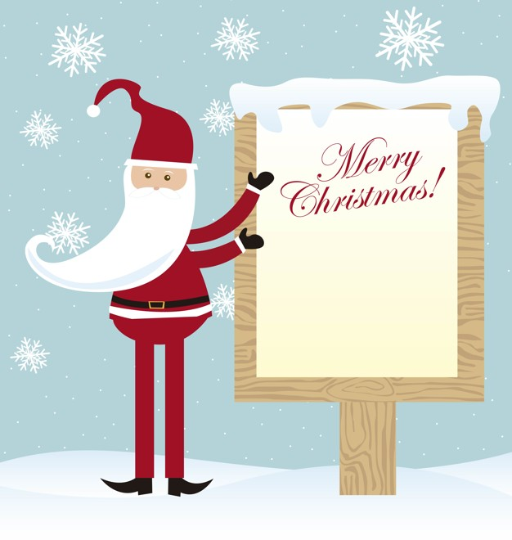

CONTACT DETAILS

St. Conleth’s National School, Derrinturn, Carbury, Co. Kildare.

Tel: 046 9553490

E-mail: [secretary@stconlethsns.ie](mailto:secretary@stconlethsns.ie)

Website: www.stconlethsns.weebly.com

**www.stconlethsns.weebly.com**





Christmas Celebration at School 11th, 12th, 13th and 18th December

P. A. Churchgate Collection 16th December

Parents Association Raffle 19th December

Christmas Jumper Day 20th December

Christmas Holidays 21st December



CONTACT DETAILS

St. Conleth’s National School, Derrinturn, Carbury, Co. Kildare.

Tel: 046 9553490

E-mail: [secretary@stconlethsns.ie](mailto:secretary@stconlethsns.ie)

Website: [www.stconlethsns.weebly.com](http://www.stconlethsns.weebly.com)