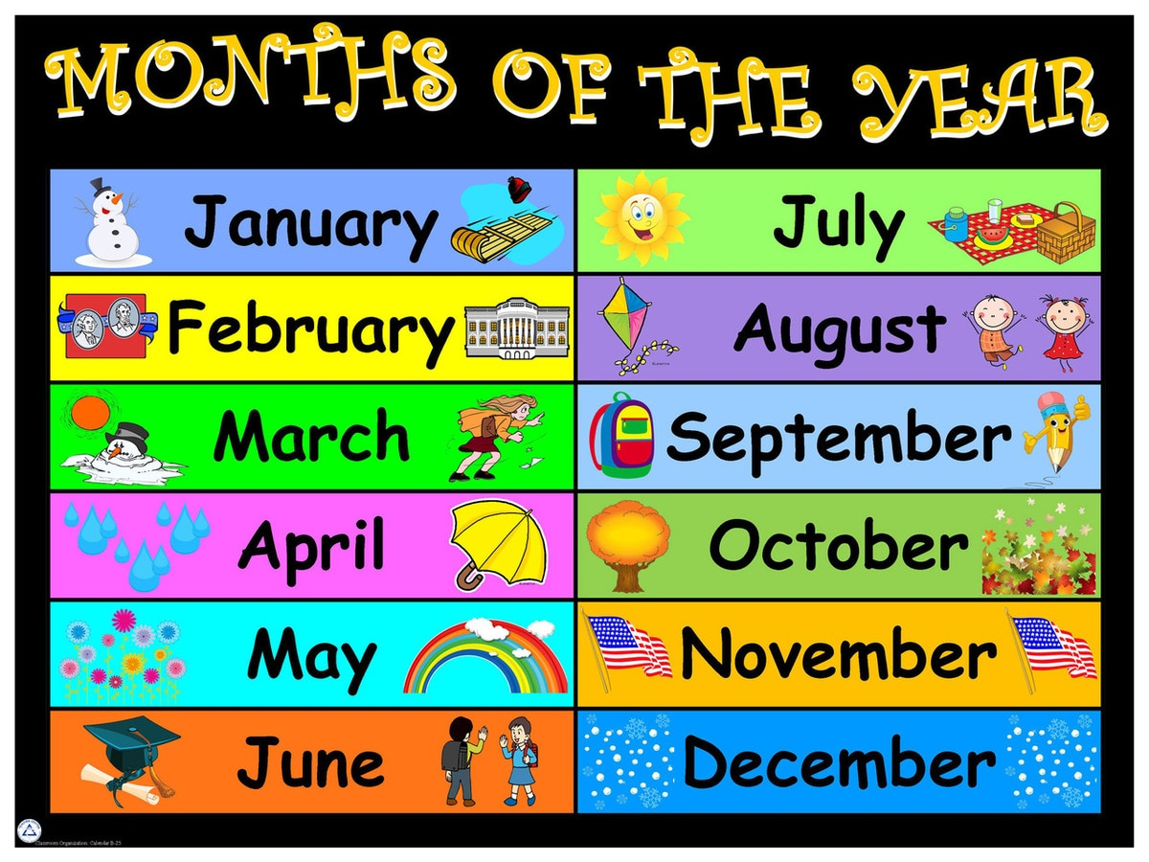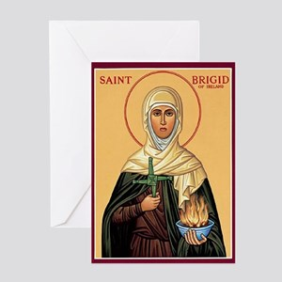

**St. Conleth’s N.S. Newsletter**

CONTENTS

   

**PAGE ONE**

Choir Excel in R.D.S.

**INSIDE SPREAD**

World Book Day Special Book Activities

**PAGE FOUR**

Trócaire 2019

Events Calendar

Contact Details

Choir Excel in R.D.S.

Our choir were incredible in the Peace Proms performance at the beginning of February. Months of rehearsal proved worthwhile as the choir proudly sang their hearts out. Every action was precise and timed to perfection. Other choirs watched carefully, taking their cue from our superstars. The singing was phenomenal and we are super-proud of all the children that represented the school so well.

We are proud to be associated with the Cross-Border Orchestra and the Peace Proms initiatives and we hope that these will be able to continue should Brexit became a reality. The lives of many have been enriched through involvement with the programmes and every participant has gained from the wonderful experience of performing in such an enormous auditorium, with a professional orchestra.

Special thanks to Mrs. O’ Donoghue, who trained the choir and worked so hard with the children. Thanks also to Teresa, our SNA, who made her Peace Proms debut this year. Everybody involved enjoyed the experience and committed so much to the event. The school thanks you all and we hope to hear a performance later in the year.

Peace Proms. Photos.

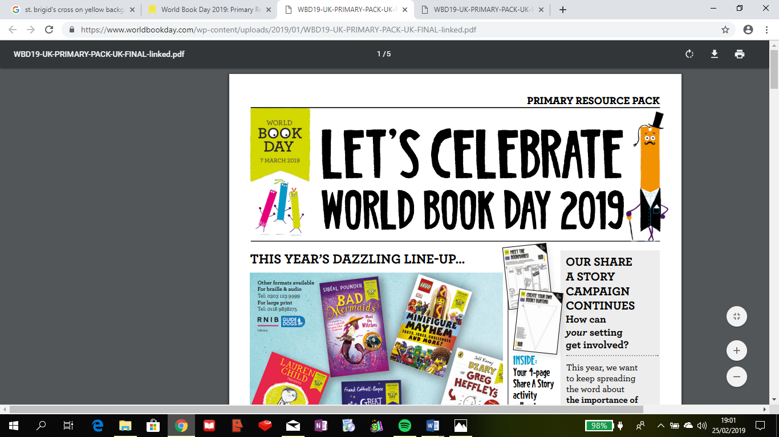

We are delighted to be celebrating World Book Day on Thursday March 7th. World Book Day has been celebrated for 22 years now. The main aim is to encourage children to explore the pleasure of books and reading by providing them with an opportunity to have a book of their own. This may sound like a very simple idea, but unfortunately, many children do not have access to books in their homes. Every year, children receive a €1.50 book token. The books below are all available by redeeming the voucher. If these books don’t appeal, the token can be used to pay towards the full price of another book.

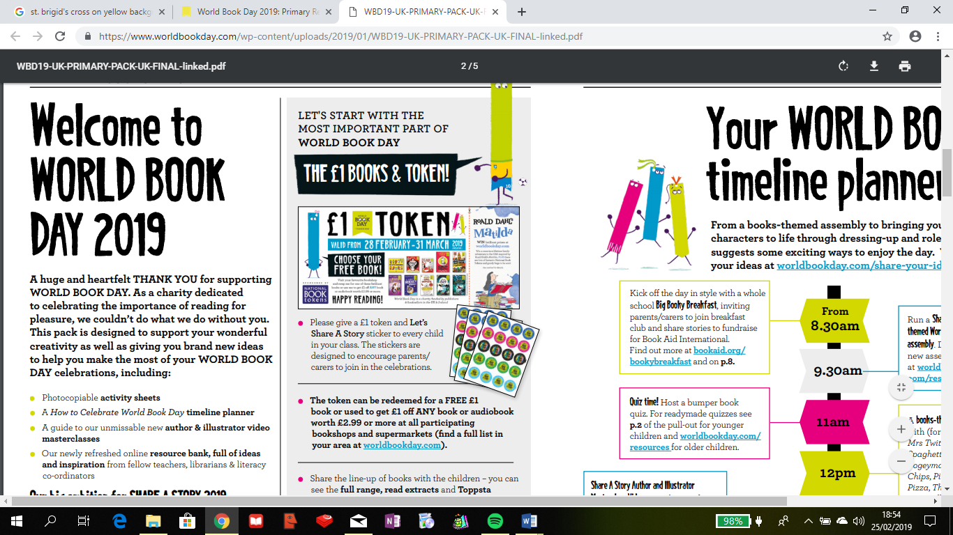 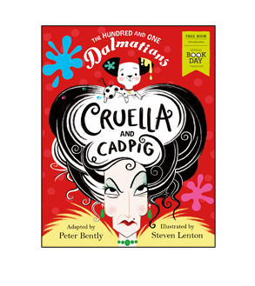 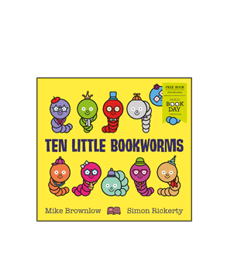

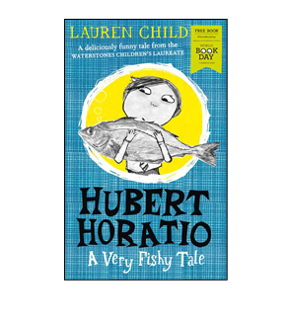 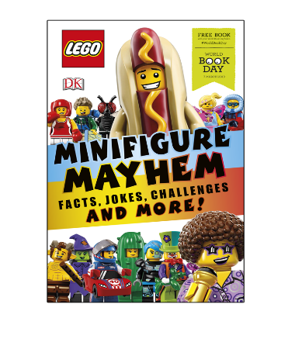 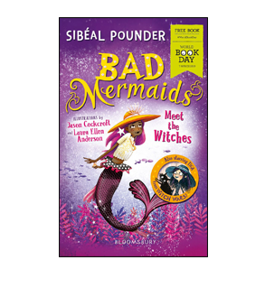 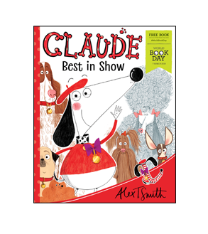 

 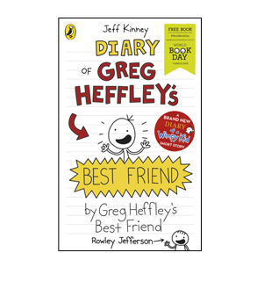 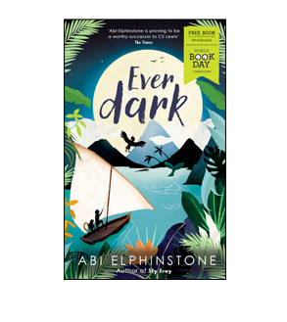 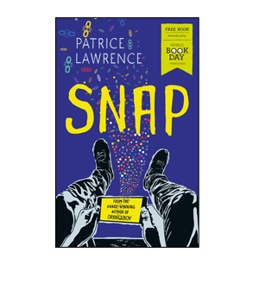 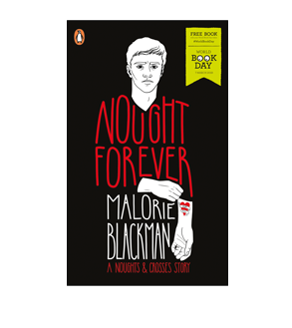 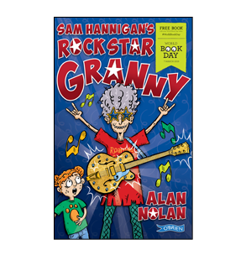

We thank National Book Tokens and all the participating book retailers. Please visit the book shops with your children so that they can use the book tokens, which will be given to the children in school.

**No Book Fair this year! Art Exhibition instead!**

This year there will not be a Book Fair at school. The Book Fair has been very beneficial in sourcing books for the library and we are very lucky to have such a wonderful resource. We thank you for the incredible support that the Book Fair has been given over the years and we guarantee that the Book Fair will return next year.

This year, however, we will hold an art exhibition at school during the final term. The featured artists will be your children and the framed masterpieces will be displayed in a beautiful gallery at school. We look forward to see all the amazing artwork on display and everyone will be invited to visit our gallery.

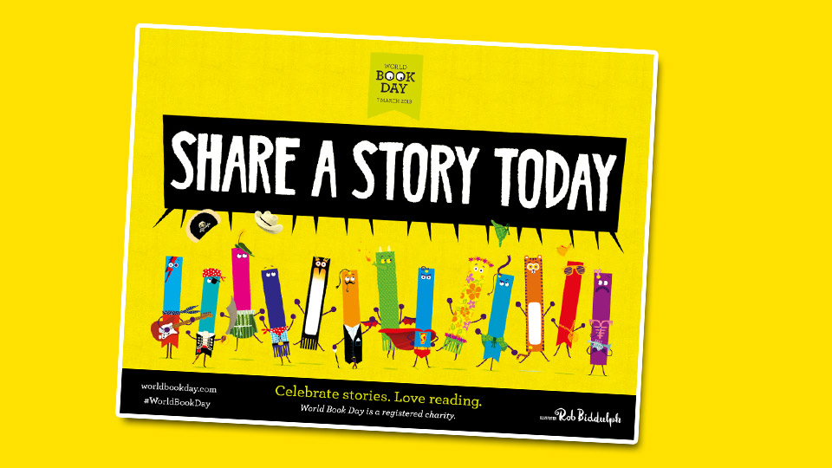

Schools, bookshops, libraries, businesses and homes nationwide are invited to join the World Book Day  **fun social event**to enjoy the pleasures of reading and **SHARE A STORY** on World Book Day… and every day. Spending **just 10 minutes a day** reading and sharing stories with children can make a crucial difference to their outcome and it’s fun for all involved. You can read together**anywhere and everywhere, from breakfast to bedtime!** In the park, on the train, on the sofa, on a plane – reading and sharing stories can happen anywhere at any time. Check out <https://www.worldbookday.com/ideas/share-a-story/> for story sharing ideas and video clips. The website has lots of fantastic ideas. Here are some of our own ideas that will help you to share the pleasure of reading with your children. We hope that you will try some of these out and have a wonderful World Book Day 2019.

Get ready to interview the main character. Prepare at least ten questions. Act out the interview for fun!

Make a list of characters that you met in the story.

Divide the list into Good guys and Baddies!

Decide what the characters might put on Snapchat or Instagram to tell their stories.

Imagine it’s ‘OPPOSITE DAY’. Change some words to tell a completely opposite version of the story.

Make a mini-book about the story. Younger children could make a picture-book. You could even do emojiis for appropriate parts of the story.

Think of a new title for the story.

Think of a new ending for the story.

During the week, the teachers will have lots of ideas to share with the children in class. It will be a wonderful week and we hope that you share stories with your children at home too.

**Trócaire 2019 – Until Love Conquers Fear.** Lent 2019 marks Trócaire’s second year of a three-year learning journey on the Global Goals for Sustainable Development (SDG’s). This year, the is focus on the theme of Land Rights. Land is a human rights and justice issue.  In our world today, one quarter of families are landless. There is no specific sustainable development goal that addresses the issue of land rights, but many of the goals can be considered land-related goals, meaning goals that cannot be achieved without addressing issues linked to land ownership and use.   The following goals have land-related targets and/or indicators:



Trócaire have prepared wonderful online resources for schools and during Lent the children will hear all about Malala Yousafzai, Brigit and Sami and the three families that are the focus for this year’s Lenten campaign, Evelyn’s Family in Uganda, José Adela and their family in Guatemala and Maya and her family in Syria. Our team of servers delivered the Trócaire Box to the school this week and we urge you to read about the plight of these poor families. They are representative of so many and we hope to support them in any way that we possibly can. Trócaire are promoting the Stations of the Cross this year and what better way to prepare for Easter during Lent than to recall this final journey of Jesus on earth. Please support Trócaire by praying the Stations of the Cross during Lent and by donating to the Trócaire Box.

 

First Confession Thursday 7th March

Staff Training Day Friday 15th March

St.Patrick’s Day Monday 18th March

Closing for Easter Holidays Friday 12th April

Re-opening after Easter Monday 29th April

First Holy Communion Saturday 25th May



**www.stconlethsns.weebly.com**



CONTACT DETAILS

St. Conleth’s National School, Derrinturn, Carbury, Co. Kildare.

Tel: 046 9553490

E-mail: [secretary@stconlethsns.ie](mailto:secretary@stconlethsns.ie)

Website: [www.stconlethsns.weebly.com](http://www.stconlethsns.weebly.com)