

**St. Conleth’s N.S. Newsletter**

CONTENTS

   



**PAGE ONE Road Safety Issues Peace Proms 2019**

**PAGE TWO Catholic Schools Week 2019 Green Schools**

**PAGE FOUR Accelerated Reading Events Calendar**

**PAGE THREE Wellbeing & Health**

**Road Safety Issues**

## At this time of year, it is quite dark in the mornings and afternoons, at arrival and leaving times. We ask you to take extra care when driving or parking near the school. Be alert and aware of young pedestrians and cyclists. Please take note of the pedestrian access routes to school and use only these for entering and leaving the premises. The staff car park has relieved congestion by removing staff cars from the road. However, it is a small car park and two-way traffic cannot be accommodated. The car park also provides necessary set-down spaces for the special class buses. Our improvements will only be effective if they are used properly. DO NOT USE THE STAFF CAR PARK AS A PEDESTRIAN ACCESS! Only members of staff and the children in their care, drive, park and alight here. In the interest of the safety of the children, we ask for your cooperation. Remind the children of these safety guidelines. **Walk Safely - stay bright both day and night. Cross safely- know the safe cross code. Cycle Safely - wear your helmet and reflective gear. Drive Safely – buckle up and fit car seats correctly. Stay Safe - Always pay attention!**

**Peace Proms 2019**

The choir sounds brilliant as we enter the final stages of preparation for the Peace Proms in the RDS on Saturday February 2nd. Mrs. O’ Donoghue and the children have been rehearsing during lunch time and we’ve all been treated to sneak previews as we listen to the beautiful songs they have been practicing. The children will represent the school very well and we will have a celebration performance in school later in the year.

We wish all our superstars the best of luck in Dublin. We hope they enjoy this opportunity to perform with a full orchestra and many other choirs from all over Ireland. Many children have never heard a live orchestral performance. So, to be part of the performance is a very special privilege indeed. We are looking forward to the concert in Dublin and we are really proud. Well done everybody. Enjoy the concert and sing your hearts out.



**Catholic Schools Week 2019**

**Celebrating the Work of Our Own Catholic School**

Each year Catholic Schools Week provides Catholic school communities with an important opportunity to celebrate ‘who they are’ and ‘what they do’. Catholic Schools Week 2019 aims to achieve this in a more meaningful way by placing each local Catholic school at the centre our celebrations. This year the theme for Catholic Schools Week 2019 is ‘Catholic Schools: Celebrating the Work of Our Own Catholic School’. Catholic schools reflect on and celebrate the relationship that exists between home, school and parish. Catholic Schools Week 2019 will run in the same format as previous years from 27 January to 3 February 2019. As in previous years, each day of Catholic Schools Week 2019 has a theme. The daily themes are: Monday: The Living Tradition of Our Catholic School Tuesday: Welcoming Diversity in Our Catholic School Wednesday: Grandparents’ Day/Intergenerational Education Thursday: Our Catholic School in Service of Our Community Friday: Celebrating Faith In Our Catholic School The children will work on these themes in school and we suggest that you talk about the activities and lessons at home. There is a very close-knit, supportive and hardworking community engaging with our school in Derrinturn. Community, school and parish links are closely interwoven and the focus of all our endeavours are the children and their wellbeing. We work together to ensure a caring, nurturing environment for our chidren. We thank you for your continued support and we hope that the activities during Catholic Schools Week will provide opportunities for us all to reflect on the work we do.

**Green Schools Update**

The school has always been a leader in Green Schools activities and Ms. Keown continues to lead the Green Schools team to new achievements, activities and explorations. Ms. Keown is currently looking at ‘Heritage in School’ programmes. There are many workshops available, that can be delivered in schools and Ms Keown is carefully evaluating available workshops. We will soon have another wonderful educational workshop at school. Cycle safety training for Sixth Class has started. This is part of the Green Schools Project and the funds raised by the clothing collection last term pays for this valuable training. Our feathered friends are getting through the cold nights of winter in beautiful new lodgings. We have received a gift of a wonderful new raised henhouse. The hens (and even the duck!) are very excited at the upgrade. We also have some new hens. The children are watching with great interest, as the newcomers make friends with our hens. Our little white hen has gone away for a little holiday. She needed a little rest away from all the hustle and bustle of the school, but we hope that she will soon regain her confidence and rejoin our merry little group of ‘eggs’troverts! Some of the children were very concerned about the little white hen when she was unwell. Sarah in fifth class recalled that her Grandad had mentioned a charity that might be able to help. She contacted Little Hill Animal Rescue and told them about our poor little hen. They offered advice and sent a lovely little jumper to keep the hen warm and cosy as she regains her strength and stamina. We thank everyone at school for showing such kindness to our little hen-friends.

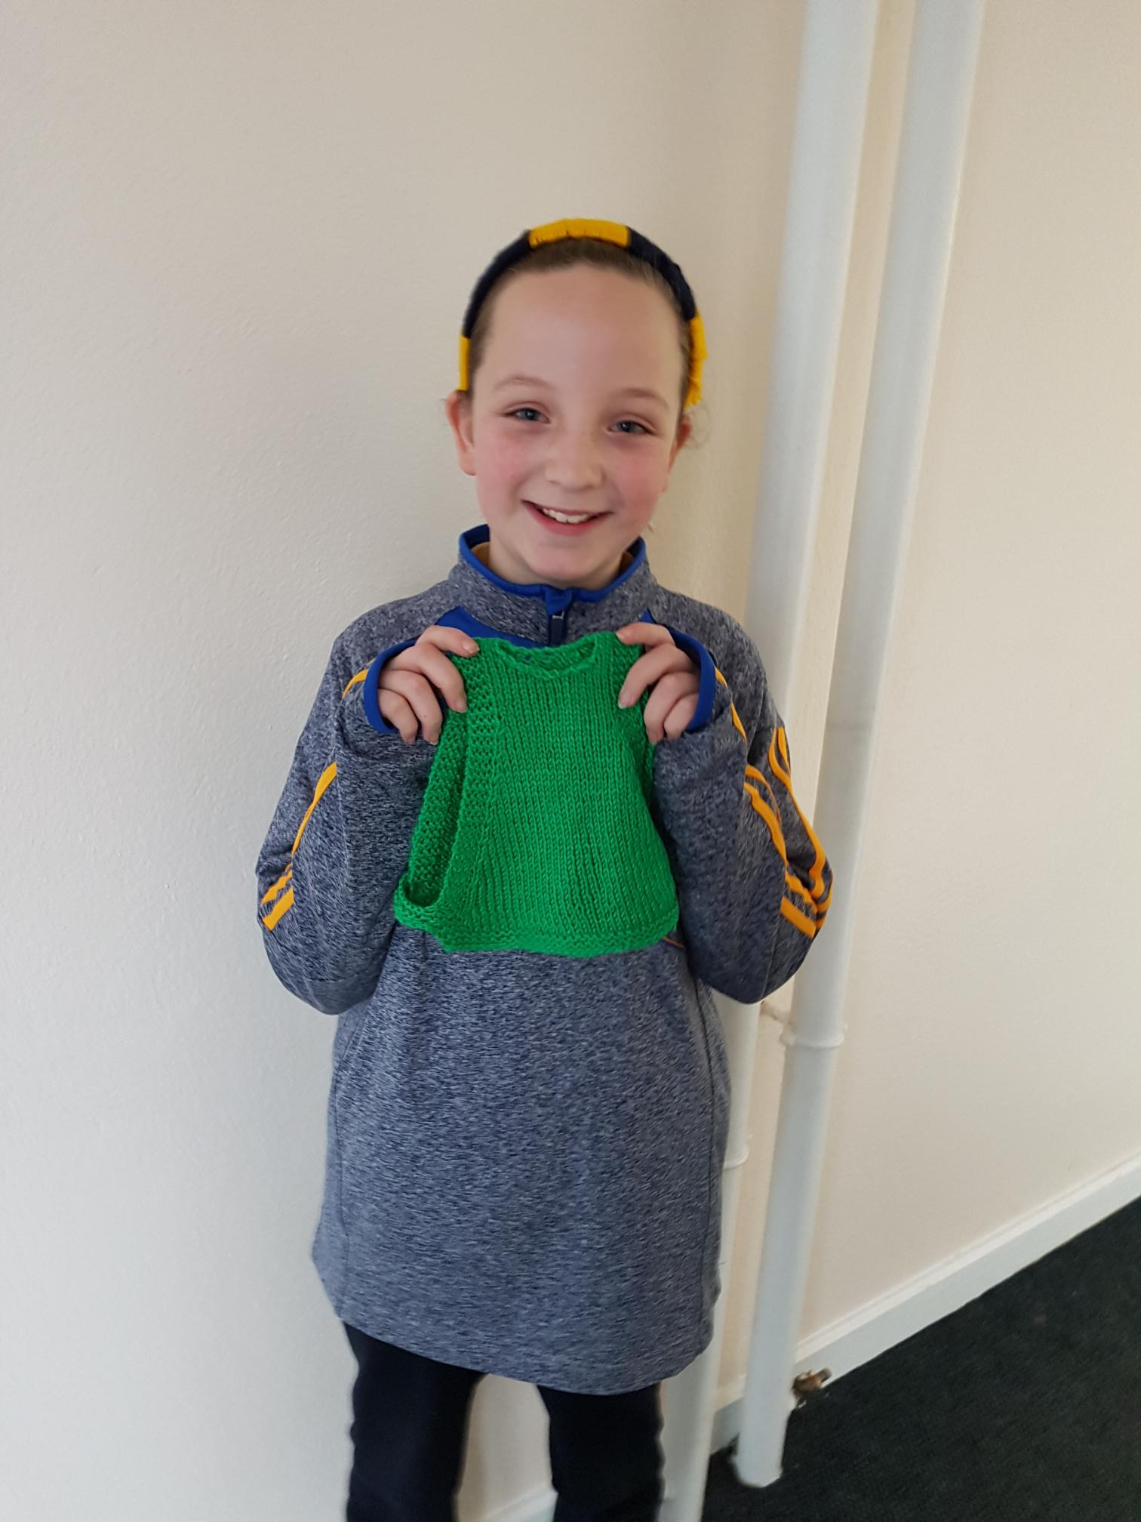

Sarah received a lovely jumper for the hen from Little Hill Animal Rescue.

**Wellbeing & Health**

As usual there are a lot of fitness and physical activities underway at school. Mrs. Kenny is ever-mindful of the need for exercise and physical fitness. Gymnastics and Tag Rugby training will continue at school. Everyone is enjoying these activities and we have been very lucky with the weather for rugby sessions. Although it has been quite cold, the rain has held off. Children from Senior Infants up to Fourth classes will soon start Gaelic training and they are very excited. We have had great interest and indeed, great success at Gaelic and it is great to see the interest continue. Swimming will start in March. It is one of the highlights of the year for all the classes and Mrs. Kenny organises the buses and sessions so that everything runs like clockwork. Letters will issue with all the relevant information before swimming classes start.

The school is participating in the Daily Mile initiative this year. The Daily Mile is a fitness, health and social activity, during which the children run, jog or walk a mile each day, at their own pace. This will happen during school hours with their classmates. Everyone has fun taking part. It is not competitive, nor strenuous. During the mile, the children have a chance to build relationships, confidence and resilience.

The fourth classes have just completed their ‘FRIENDS for Life Programme’. This is a school-based positive mental health programme. The World Health Organisation cites ‘FRIENDS for Life’ as the only evidence-based programme effective at all levels of intervention for anxiety in children (WHO 2004). The programme helps students to develop effective strategies to deal with worry, stress and change and teaches the skills required to reduce anxiety and promote resilience. It is beneficial for all students. The word ‘FRIENDS’ is an acronym that helps children and perhaps, all of us to remember the coping steps to follow:

**F -** Feeling Worried?

**R -** Relax and feel good.

**I -** I can do it!

**E -** Explore solutions and coping step plans.

**N -** Now reward yourself.

**D –** Don’t forget to practice**.**

**S -** Stay cool!

The staff of St. Conleth’s National School are very aware of recent articles in the media about flu and other illnesses. We take this opportunity to remind you of tips to prevent the spread of flu. 1. Practice good hand hygiene by washing your hands often with soap and water, especially after coughing or sneezing. Hand drying facilities at school are single-use disposable sheets. 2. Cover your mouth and nose with a tissue when you cough or sneeze. Dispose of (get rid of) tissues immediately as household rubbish (a regular dustbin is fine) in the normal way. If you don’t have a tissue, cough or sneeze into your elbow or shoulder, not into your hands. 3. Do not share wind instruments. Avoid sharing pencils, crayons, pens, toys/objects where possible and, if sharing them, clean them before passing them between students. 4. If you have symptoms of flu, you should not attend school when you have symptoms. 5. If you have suspected flu or flu, you should remain at home until you are well enough to return usually for 5 to 7 days from when symptoms began. Do not return to school if you have a fever i.e. temperature of 38ºC/100ºF or over. Rest assured that the school will make contact with you if your chid is sick. **Please make sure that the contact numbers you have submitted are correct and up to date.**

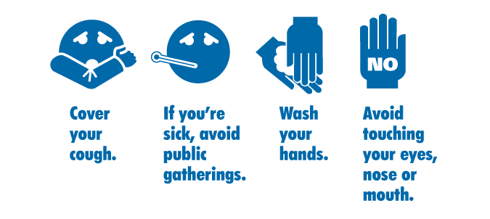

**Accelerated Reading**

##### As a DEIS school, our literacy strategy has clear targets, including raising attainment in reading. We are starting a programme called Accelerated Reader for the children in the school. Children from Second class up to Sixth class participate in the programme. Our new library houses a huge collection of books and these will be used as part of the Accelerated Reading process. At its heart, Accelerated Reader is simple. A student reads a book, takes an online quiz, and gets immediate feedback. Students respond to regular feedback and are motivated to make progress with their reading skills. Accelerated Reader gives teachers the information they need to monitor students’ reading practice and make informed decisions to guide their future learning. A comprehensive set of reports reveals how much a student has been reading, at what level of complexity, and how well they have understood what they have read. Vocabulary growth and literacy skills are also measured, giving teachers insight into how well students have responded to reading schemes and class instruction. We have the books required in the library and online training has been ongoing to set up the individual readers and log the books that we have. We are also going to provide a set of tablets so that the children can access the programme in school and continue reading and testing. The children will also be able to use the programme at home, as they will have access from devices at home. Accelerated Reading can improve the reading age of pupils significantly. Pupils develop reading skills most effectively when they read appropriately challenging books – difficult enough to keep them engaged but not so difficult that they become frustrated. The children have begun the Star Reading challenge and will soon be up and running with this fun-filled programme.

**www.stconlethsns.weebly.com**

 

CONTACT DETAILS

St. Conleth’s National School, Derrinturn, Carbury, Co. Kildare.

Tel: 046 9553490

E-mail: [secretary@stconlethsns.ie](mailto:secretary@stconlethsns.ie)

Website: www.stconlethsns.weebly.com

**Please remember these important dates.**

 

Catholic Schools Week Monday 28th January – Friday 1st February

Peace Proms in the R.D.S. Saturday 2nd February

Parents Association Meeting Tuesday 12th February

Mid-Term Break Thursday 21st & Friday 22nd February

Confirmation Wednesday 27th February

First Confession Thursday 7th March

St.Patrick’s Day Monday 18th March

Closing for Easter Holidays Friday 12th April

Re-opening after Easter Monday 29th April

First Holy Communion Saturday 25th May